**Practicing IPv4 Subnetting**

Given a network topology as below:

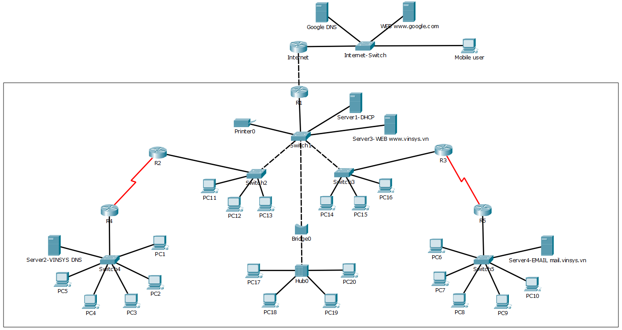

and with a major network 193.169.1.0/24. You, as a network engineer, must to create a IPv4 planning properly.

**The Practice 1: using FLSM for subnetting**

1. Answer following questions

|  |  |
| --- | --- |
| What’s the default subnetmask ? | 255.255.255.0 |
| How many subnet will you need ? | 5 |
| What’s the minimum number of bits for subnetting ? | 3 |
| What will the subnetmask be ? | 255.255.255.224 |
| How many usabe subnet has been created ? | 8 |
| How many valid IP address in each subnet ? | 30 |

1. Fill the below table up to eight subnets that can be created, starting from subnet # 0

|  |  |  |  |  |  |
| --- | --- | --- | --- | --- | --- |
| **Sub-**  **-net** | **Network Address** | **Range of Host Address** | **Broadcast Address** | **Usable (Y/N)** | **Used (Y/N)** |
| #0 | 193.169.1.0 | 193.169.1.1 - 193.169.1.30 | 193.169.1.31 | Y | Y |
| #1 | 193.169.1.32 | 193.169.1.33 - 193.169.1.62 | 193.169.1.63 | Y | Y |
| #2 | 193.169.1.64 | 193.169.1.65 - 193.169.1.94 | 193.169.195 | Y | Y |
| #3 | 193.169.1.96 | 193.169.1.97 - 193.169.1.126 | 193.169.1.127 | Y | Y |
| #4 | 193.169.1.128 | 193.169.1.129 - 193.169.1.158 | 193.169.1.159 | Y | Y |
| #5 | 193.169.1.160 | 193.169.1.161 - 193.169.1.190 | 193.169.1.191 | Y | N |
| #6 | 193.169.1.192 | 193.169.1.193 - 193.169.1.222 | 193.169.1.223 | Y | N |
| #7 | 193.169.1.224 | 193.169.1.225 - 193.169.1.254 | 193.169.1.255 | Y | N |

1. Assign an IP address and subnet mask to router interfaces, VLAN 1 of switchs, and servers

|  |  |  |  |  |
| --- | --- | --- | --- | --- |
| **Device** | **Interface** | **IP Address** | **Subnet Mask** | **Default Gateway** |
| **R1** | F0/0 |  |  |  |
| **R2** | F0/0 |  |  |  |
| S0/0/0 |  |  |  |
| **R3** | F0/0 |  |  |  |
| S0/0/0 |  |  |  |
| **R4** | F0/0 |  |  |  |
| S0/0/0 |  |  |  |
| **R5** | F0/0 |  |  |  |
| S0/0/0 |  |  |  |
| **SW1** | VLAN 1 |  |  |  |
| **SW2** | VLAN 1 |  |  |  |
| **SW3** | VLAN 1 |  |  |  |
| **SW4** | VLAN 1 |  |  |  |
| **Ser1-DHCP** |  |  |  |  |
| **Ser2-DNS** |  |  |  |  |
| **Ser3-WEB** |  |  |  |  |
| **Ser4-EMAIL** |  |  |  |  |

**The Practice 2: using VLSM for subnetting**

1. Determine size of networks

|  |  |  |
| --- | --- | --- |
| **ID** | **Network** | **Number of hosts** |
| 1 | **LAN R1-R2-R3** | 30 |
| 2 | **LAN R4** | 14 |
| 3 | **LAN R5** | 14 |
| 4 | **Link R2-R4** | 2 |
| 5 | **Link R3-R5** | 2 |

1. Fill the below table up to eight subnets that can be created, starting from subnet # 0

|  |  |  |  |  |
| --- | --- | --- | --- | --- |
| **ID** | **Network** | **Network Address** | **Range of Host Address** | **Broadcast Address** |
| 1 | **LAN R1-R2-R3** | 193.169.1.0/27 | 193.169.1.1 – 193.169.1.30 | 193.169.1.31 |
| 2 | **LAN R4** | 193.169.1.32/28 | 193.169.1.33 - 193.169.1.46 | 193.169.1.47 |
| 3 | **LAN R5** | 193.169.1.48/28 | 193.169.1.49 - 193.169.1.62 | 193.169.1.63 |
| 4 | **Link R2-R4** | 193.169.1.64/30 | 193.169.1.65 - 193.169.1.66 | 193.169.1.67 |
| 5 | **Link R3-R5** | 193.169.1.68/30 | 193.169.1.69 - 193.169.1.70 | 193.169.1.71 |

1. Assign an IP address and subnet mask to router interfaces, VLAN 1 of switchs, and servers

|  |  |  |  |  |
| --- | --- | --- | --- | --- |
| **Device** | **Interface** | **IP Address** | **Subnet Mask** | **Default Gateway** |
| **R1** | F0/0 |  |  |  |
| **R2** | F0/0 |  |  |  |
| S0/0/0 |  |  |  |
| **R3** | F0/0 |  |  |  |
| S0/0/0 |  |  |  |
| **R4** | F0/0 |  |  |  |
| S0/0/0 |  |  |  |
| **R5** | F0/0 |  |  |  |
| S0/0/0 |  |  |  |
| **SW1** | VLAN 1 |  |  |  |
| **SW2** | VLAN 1 |  |  |  |
| **SW3** | VLAN 1 |  |  |  |
| **SW4** | VLAN 1 |  |  |  |
| **Ser1-DHCP** |  |  |  |  |
| **Ser2-DNS** |  |  |  |  |
| **Ser3-WEB** |  |  |  |  |
| **Ser4-EMAIL** |  |  |  |  |